## Insurance Database

**Question**

* PERSON (driver_id: String, name: String, address: String)
* CAR (reg_num: String, model: String, year: int)
* ACCIDENT (report_num: int, accident_date: date, location: String)
* OWNS (driver_id: String, reg_num: String)
* PARTICIPATED (driver_id: String,reg_num: String, report_num: int, damage_amount: int)
* Create the above tables by properly specifying the primary keys and the foreign keys. **-**

Enter at least five tuples for each relation

* Display Accident date and location
* Update the damage amount to 25000 for the car with a specific reg_num (example 'K A031181' ) for which the accident report number was 12.
* Add a new accident to the database.
* To Do
* Display Accident date and location
* Display driver_id who did accident with damage amount greater than or equal to

Rs.25000

### Schema Diagram

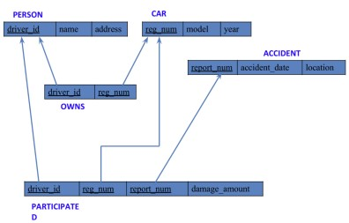

### Create database

### create database insurance_1BM23CS081;

### use insurance_1BM23CS081;

### Create table

create table PERSON_081(

driver_id varchar(20),

name varchar(30),

address varchar(100),

primary key (driver_id));

create table CAR_081(

reg_num varchar(20),

model varchar (10),

year int,

Primary key (req_num));

create table ACCIDENT_081(

report_num int,

accident_date date,

location varchar (100),

primary key (report_num));

create table OWNS_081(

driver_id varchar(20),

reg_num varchar(20),

primary key (driver_id, reg_num),

foreign key (driver_id) references PERSON_081 (driver_id),

foreign key (reg_num) references CAR_081(reg_num));

create table PARTICIPATED_081(

driver_id varchar (20),

reg_num varchar(20),

report_num int,

damage_amount int,

primary key (driver_id, reg_num, report_num),

foreign key (driver_id) references PERSON_081 (driver_id),

foreign key (reg_num) references CAR_081 (reg_num),

foreign key (report_num) references ACCIDENT_081 (report_num));

### Structure of the table

PERSON_081

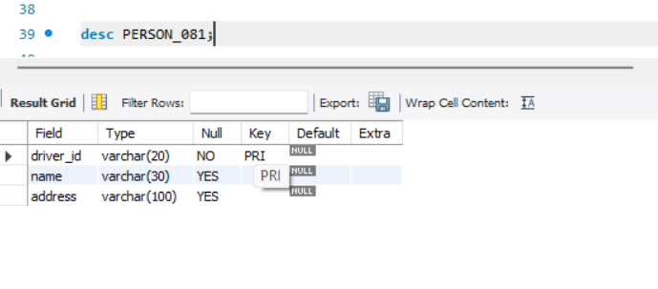

ACCIDENT_081

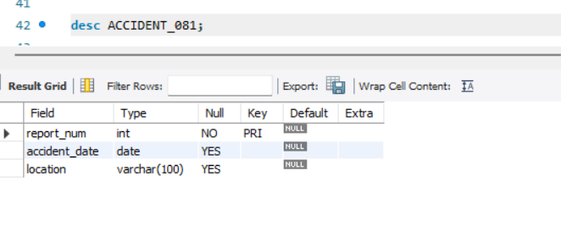

PARTICIPATED_081

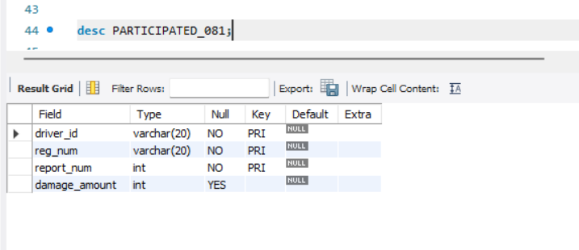

CAR_081

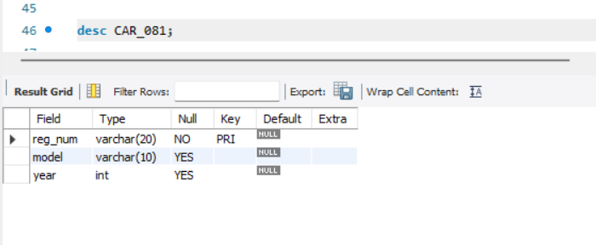

OWNS_081

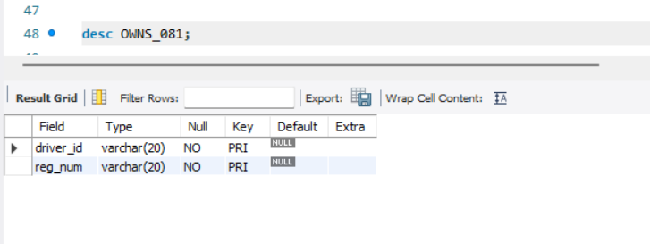

### Inserting Values into the table

insert into PERSON_081 values

("A01", "Richard", "Sri Nagar"),

("A02", "Pradeep", "Raj Nagar"),

("A03", "Smith", "Ashok Nagar"),

("A04", "Venu", "N R Colony"),

("A05", "John", "Hanu Nagar");

insert into CAR_081 values

("KA052250", "Indica", 1990),

("KA031181", "Lancer", 1957),

("KA095477", "Toyota", 1998),

("KA053408", "Honda", 2008),

("KA041702", "Audi", 2005);

insert into OWNS_081 values

("A01", "KA052250"),

("A02", "KA031181"),

("A03", "KA095477"),

("A04", "KA053408"),

("A05", "KA041702");

insert into ACCIDENT_081 values

(11, "01-01-03", "Mysore Rd"),

(12, "02-02-04", "SE Circle"),

(13, "21-01-03", "Bull Temple Rd"),

(14, "17-02-08", "Mysore Rd"),

(15, "04-03-05", "KR Puram");

insert into PARTICIPATED_081 values

("A01", "KA052250", 11, 10000),

("A02", "KA031181", 12, 50000),

("A03", "KA053408", 13, 25000),

("A04", "KA095477", 14, 3000),

("A05", "KA041702", 15, 5000);

**INSERTED VALUES**

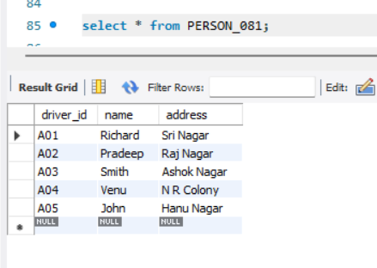

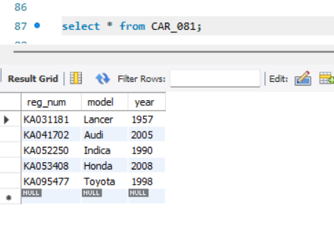

### 

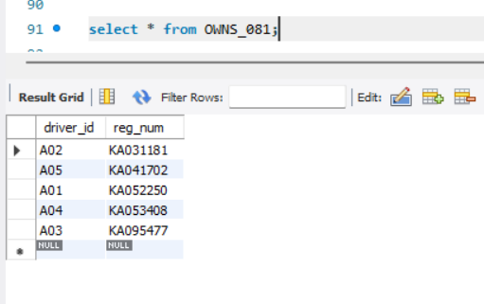

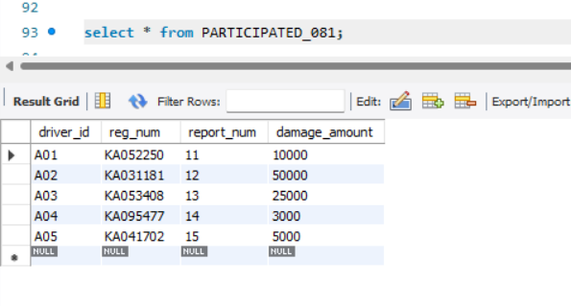

### Queries

**1. Update the damage amount to 25000 for the car with a specific reg-num (example 'KA031181' ) for which the accident report number was 12.**

Query : update PARTICIPATED_081 set damage_amount = 25000 where reg_num = "KA031181" and report_num = 12;

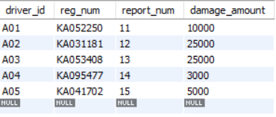

**2.** **Display Accident date and location**

Query : select accident_date, location from ACCIDENT_081;

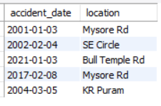

**3.Add a new accident to the database.**

Query : insert into ACCIDENT_081

values (16, "01-01-10", "BTM");

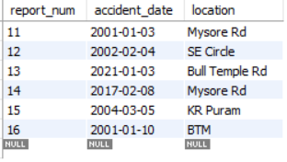

**4.Display driver id who did the accident damage greater than or equal to Rs.25000**

Query : select driver_id

from PARTICIPATED_081

where damage_amount >=25000;

